**PART A**

**EXPERIMENT NO. 4**

**A.1 Aim: - Modeling UML Class diagrams.**

**A.2 Prerequisite**

**1. Concepts of Actor, Use Case and Relationships**

**A.3 Outcome**

After successful completion of this experiment students will be able to

Design solution using unified modeling language.

**A.4 Task:**

For the problem statement in Handout attached,

1. Write CRC card.
2. Complete Class Diagram in StarUML.

**PART B**

|  |  |
| --- | --- |
| Roll No: B017 | Name: Niharika Dalal |
| Class: B. Tech. Comp. Engg. | Batch: B1 |
| Date of Experiment: 21.2.2016 | Date of Submission: |
| Grade: |  |

**B.1 Actors:**

* **Server**

**B.2 Class Diagram:**

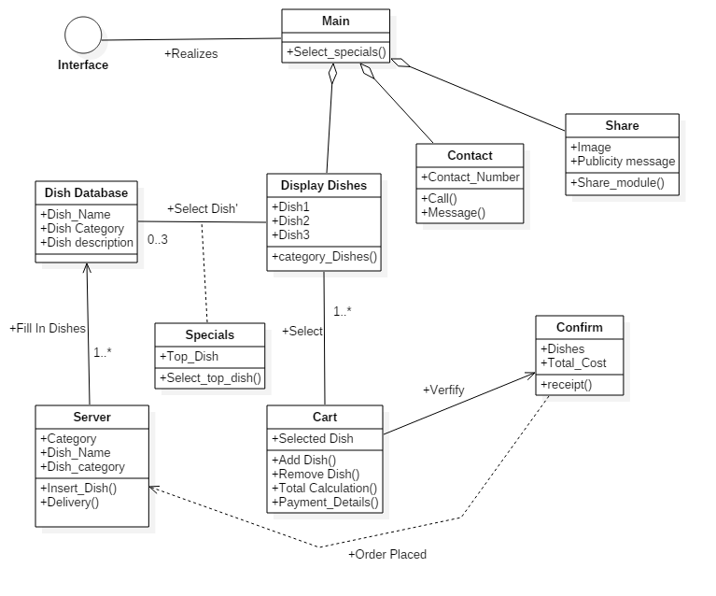

**B.3 Entity Classes:**

* **Dish Database**
* **Display Dishes**
* **Cart**

**B.4 Boundary Classes:**

* **Main**

**B.5 Control Classes:**

* **Server**
* **Contact**
* **Share**
* **Confirm**

**B.6 Conclusion**

**………………………………………………………………………………………………………**

**In this practical, we have created the class diagram for a bakery mobile application. A class diagram represents the static view of an application. It is used for visualizing and describing different aspects of a software system. It is also known as a structural diagram.**

**The responsibilities of a class diagram include:**

* **Describing responsibilities of a system.**
* **Forward and reverse engineering.**
* **It is the base for component and deployment diagrams.**

**………………………………………………………………………………………………………**